**Spring Annotation base Configuration**

1. **Spring Annotation Base là gì**

* Từ Spring 2.5 trở đi thì có thể config Depedency injection bằng cách dùng Annotations. Thay vì dùng XML để mô tả Bean thì ta có thể dời toàn bộ Bean config vào chung trong Class thực thi của Bean đó bằng cách dùng annotation ở level class, method, field
* Ví dụ:
* Có 1 class Student.java như sau

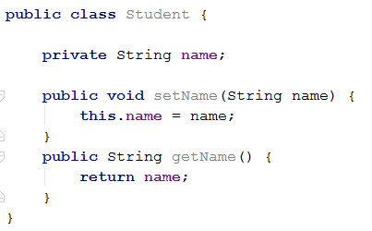

* Có 2 cách để định nghĩa class Student là **Bean:** dùng **XML** hoặc **Annotation**
* **Dùng XML**

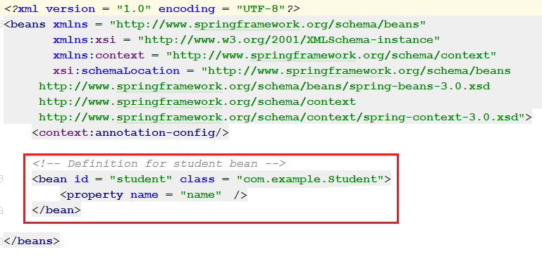

* **Dùng Annotation**

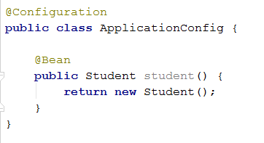

* Annotation injection được run trước XML injection. Do đó nếu như 1 bean được định nghĩa bằng cả 2 annotation và XML thì XML injection sẽ override lại Annotation injection
* Mặc định thì Annotation sẽ không được turn on, và nếu muốn sử dụng thì phải bật Annotation bằng cách chỉ định trong Spring configuration file như sau:

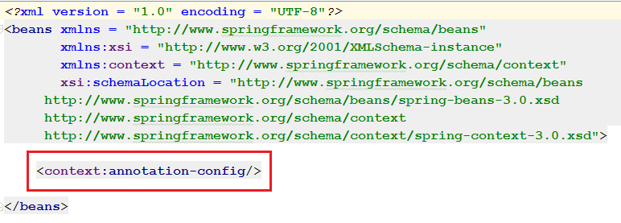

1. **Vài Annotation quan trọng**

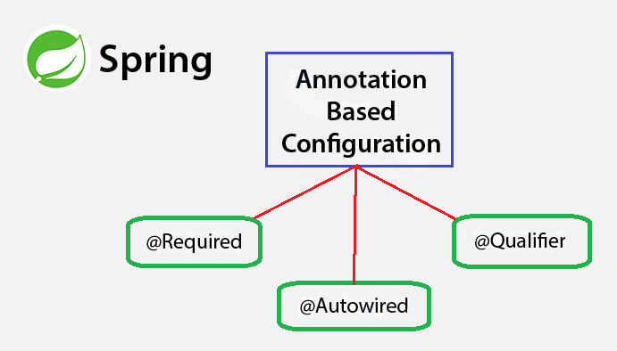

**2.1 @Required**

Được dùng cho method **setter** của **Bean property**, chỉ định việc bắc buộc property của Bean phải được định nghĩa trong file XML config. Có nghĩa là object class Student có 1 property “name”, khi dùng @Required thì property “name” bắc buộc phải được định nghĩa trong file XML config. Nếu không có nó sẽ throw exception **BeanInitializationException**

Student.java

public class Student {

private String name;

**@Required**

public void setName(String name) {

this.name = name;

}

public String getName() {

return name;

}

}

MainApp.java

public class MainApp {

public static void main(String[] args) {

ApplicationContext context = new ClassPathXmlApplicationContext("Beans.xml");

Student student = (Student) context.getBean("student");

System.out.println("Name : " + student.getName() );

}

}

Beans.xml

<?xml version = "1.0" encoding = "UTF-8"?>

<beans xmlns = "http://www.springframework.org/schema/beans"

xmlns:xsi = "http://www.w3.org/2001/XMLSchema-instance"

xmlns:context = "http://www.springframework.org/schema/context"

xsi:schemaLocation = "http://www.springframework.org/schema/beans

http://www.springframework.org/schema/beans/spring-beans-3.0.xsd

http://www.springframework.org/schema/context

http://www.springframework.org/schema/context/spring-context-3.0.xsd">

<context:annotation-config/>

<!-- Definition for student bean -->

<bean id = "student" class = " spring.example.Student">

</bean>

</beans>

* Nếu không định nghĩa property “name” thì sẽ throw exception **BeanInitializationException,** bởi vì trong class **Student.java** đang định nghĩa **@Required** cho method **setName()**
* File **Bean.xml** sẽ fix như sau:

<?xml version = "1.0" encoding = "UTF-8"?>

<beans xmlns = "http://www.springframework.org/schema/beans"

xmlns:xsi = "http://www.w3.org/2001/XMLSchema-instance"

xmlns:context = "http://www.springframework.org/schema/context"

xsi:schemaLocation = "http://www.springframework.org/schema/beans

http://www.springframework.org/schema/beans/spring-beans-3.0.xsd

http://www.springframework.org/schema/context

http://www.springframework.org/schema/context/spring-context-3.0.xsd">

<context:annotation-config/>

<!-- Definition for student bean -->

<bean id = "student" class = " spring.example.Student">

<property name = "name" value = "Mr.Bean" />

</bean>

</beans>

Kết quả run:

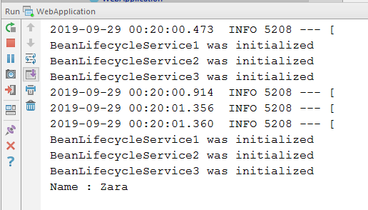

**2.2 @Autowired**

- @Autowired là cách inject tự động vào Bean, khác với @Required chỉ hỗ trợ setter method thì @Autowired được hỗ trợ rộng hơn: setter method, constructor, property

**@Autowired on Setter Methods**

***TextEditor.java***

public class TextEditor {

private SpellChecker spellChecker;

@Autowired

public void setSpellChecker( SpellChecker spellChecker ){

this.spellChecker = spellChecker;

}

public SpellChecker getSpellChecker( ) {

return spellChecker;

}

public void spellCheck() {

spellChecker.checkSpelling();

}

}

**SpellChecker.java**:

public class SpellChecker {

public SpellChecker(){

System.out.println("Inside SpellChecker constructor." );

}

public void checkSpelling(){

System.out.println("Inside checkSpelling." );

}

}

**MainApp.java**

public class MainApp {

public static void main(String[] args) {

ApplicationContext context = new ClassPathXmlApplicationContext("Beans.xml");

TextEditor text = (TextEditor) context.getBean("textEditor");

text.spellCheck();

}

}

**Beans.xml**

<?xml version = "1.0" encoding = "UTF-8"?>

<beans xmlns = "http://www.springframework.org/schema/beans"

xmlns:xsi = "http://www.w3.org/2001/XMLSchema-instance"

xmlns:context = "http://www.springframework.org/schema/context"

xsi:schemaLocation = "http://www.springframework.org/schema/beans

http://www.springframework.org/schema/beans/spring-beans.xsd

http://www.springframework.org/schema/context

http://www.springframework.org/schema/context/spring-context.xsd">

<context:annotation-config/>

<!-- Definition for textEditor bean without constructor-arg -->

<bean id = "textEditor" class = " spring.example.TextEditor">

</bean>

<!-- Definition for spellChecker bean -->

<bean id = "spellChecker" class = "spring.example.SpellChecker">

</bean>

</beans>

**Kết quả**

Inside SpellChecker constructor.

Inside checkSpelling.

**@Autowired on Property**

**TextEditor.java**

public class TextEditor {

@Autowired

private SpellChecker spellChecker;

public TextEditor() {

System.out.println("Inside TextEditor constructor." );

}

public SpellChecker getSpellChecker( ){

return spellChecker;

}

public void spellCheck(){

spellChecker.checkSpelling();

}

}

**Beans.xml**

<?xml version = "1.0" encoding = "UTF-8"?>

<beans xmlns = "http://www.springframework.org/schema/beans"

xmlns:xsi = "http://www.w3.org/2001/XMLSchema-instance"

xmlns:context = "http://www.springframework.org/schema/context"

xsi:schemaLocation = "http://www.springframework.org/schema/beans

http://www.springframework.org/schema/beans/spring-beans.xsd

http://www.springframework.org/schema/context

http://www.springframework.org/schema/context/spring-context.xsd">

<context:annotation-config/>

<!-- Definition for textEditor bean -->

<bean id = "textEditor" class = "spring.example.TextEditor">

</bean>

<!-- Definition for spellChecker bean -->

<bean id = "spellChecker" class = "spring.example.SpellChecker">

</bean>

</beans>

**Kết quả**

Inside TextEditor constructor.

Inside SpellChecker constructor.

Inside checkSpelling.

**@Autowired on Constructor**

**TextEditor.java**

public class TextEditor {

private SpellChecker spellChecker;

@Autowired

public TextEditor(SpellChecker spellChecker){

System.out.println("Inside TextEditor constructor." );

this.spellChecker = spellChecker;

}

public void spellCheck(){

spellChecker.checkSpelling();

}

}

**Beans.xml**

<?xml version = "1.0" encoding = "UTF-8"?>

<beans xmlns = "http://www.springframework.org/schema/beans"

xmlns:xsi = "http://www.w3.org/2001/XMLSchema-instance"

xmlns:context = "http://www.springframework.org/schema/context"

xsi:schemaLocation = "http://www.springframework.org/schema/beans

http://www.springframework.org/schema/beans/spring-beans.xsd

http://www.springframework.org/schema/context

http://www.springframework.org/schema/context/spring-context.xsd">

<context:annotation-config/>

<!-- Definition for textEditor bean without constructor-arg -->

<bean id = "textEditor" class = " spring.example.TextEditor">

</bean>

<!-- Definition for spellChecker bean -->

<bean id = "spellChecker" class = "spring.example.SpellChecker">

</bean>

</beans>

**Kết Quả**

Inside SpellChecker constructor.

Inside TextEditor constructor.

Inside checkSpelling.

**2.2 @Qualifier**

Trường hợp khi tạo nhiều Bean có cùng 1 kiểu dữ liệu, thì khi autowired sẽ có vấn đề phát sinh là Không biết wiring vào Bean nào. Khi đó phải dùng **@Qualifier** để xác định Bean theo name

**Student.java**

public class Student {

private Integer age;

private String name;

public void setAge(Integer age) {

this.age = age;

}

public Integer getAge() {

return age;

}

public void setName(String name) {

this.name = name;

}

public String getName() {

return name;

}

}

**Profile.java**

public class Profile {

@Autowired

@Qualifier("student1")

private Student student;

public Profile(){

System.out.println("Inside Profile constructor." );

}

public void printAge() {

System.out.println("Age : " + student.getAge() );

}

public void printName() {

System.out.println("Name : " + student.getName() );

}

}

**MainApp.java**

public class MainApp {

public static void main(String[] args) {

ApplicationContext context = new ClassPathXmlApplicationContext("Beans.xml");

Profile profile = (Profile) context.getBean("profile");

profile.printAge();

profile.printName();

}

}

**Beans.xml**

<?xml version = "1.0" encoding = "UTF-8"?>

<beans xmlns = "http://www.springframework.org/schema/beans"

xmlns:xsi = "http://www.w3.org/2001/XMLSchema-instance"

xmlns:context = "http://www.springframework.org/schema/context"

xsi:schemaLocation = "http://www.springframework.org/schema/beans

http://www.springframework.org/schema/beans/spring-beans-3.0.xsd

http://www.springframework.org/schema/context

http://www.springframework.org/schema/context/spring-context-3.0.xsd">

<context:annotation-config/>

<!-- Definition for profile bean -->

<bean id = "profile" class = "com.tutorialspoint.Profile"></bean>

<!-- Definition for student1 bean -->

<bean id = "student1" class = "com.tutorialspoint.Student">

<property name = "name" value = "Zara" />

<property name = "age" value = "11"/>

</bean>

<!-- Definition for student2 bean -->

<bean id = "student2" class = "com.tutorialspoint.Student">

<property name = "name" value = "Nuha" />

<property name = "age" value = "2"/>

</bean>

</beans>

Kết quả

Inside Profile constructor.

Age : 11

Name : Zara

* **Tài liệu tham khảo**

<https://docs.spring.io/spring/docs/3.0.0.M3/reference/html/ch04s11.html>